**FAKE NEWS DETECTION**

1. Deepthi Bodapati (700734601) 2. Yeshwanth Reddy Kunam (700731889)

3. Bytinty Siva Prasad Reddy (700734604) 4. Mohith Medikonda (700734518)

​

Abstract

Automatic fake news detection is a challenging problem in deception detection, and it has tremendous real-world political and social impacts. However, statistical approaches to combating fake news has been dramatically limited by the lack of labeled benchmark datasets. In this paper, we present liar: a new, publicly available dataset for fake news detection. Which provides detailed analysis report and links to source documents for each case. This dataset can be used for fact-checking research as well. Notably, this new dataset is an order of magnitude larger than previously largest public fake news datasets of similar type. Empirically, we investigate automatic fake news detection based on surface-level linguistic patterns. We have designed a novel, hybrid convolutional neural network to integrate meta-data with text. We show that this hybrid approach can improve a text-only deep learning model.

Introduction :

People nowadays tend to seek out and consume news from social media rather than traditional news organizations. For example, 62% of U.S. adults get news on social media in 2016, while in 2012, only 49 percent reported seeing news on social media1 . However, social media for news consumption is a double-edged sword. The quality of news on social media is much lower than traditional news organizations.

Large volumes of “fake news”, i.e., those news articles with intentionally false information, are produced online for a variety of purposes, such as financial and political gain (Klein and Wueller 2017; Allcott and Gentzkow 2017). Fake news can have detrimental effects on individuals and the society. First, people may be misled by fake Copyright c 2018, Association for the Advancement of Artificial Intelligence (www.aaai.org). All rights reserved. 1 http://www.journalism.org/2016/05/26/news-use-acrosssocial-media-platforms-2016/ news and accept false beliefs (Nyhan and Reifler 2010; Paul and Matthews 2016). Second, fake news could change the way people respond to true news2 . Third, the widespread of fake news could break the trustworthiness of entire news ecosystem. Thus, it is important to detect fake news on social media. Fake news is intentionally written to mislead consumers, which makes it nontrivial to detect simply based on news content. Thus, it is necessary to explore auxiliary information to improve detection. For example, several style-based approaches try to capture the deceptive manipulators originated from the particular writing style of fake news (Rubin and Lukoianova 2015; Potthast et al. 2017). In addition, previous approaches try to aggregate users’ responses from relevant social engagements to infer the veracity of original news (Castillo, Mendoza, and Poblete 2011; Gupta, Zhao, and Han 2012). The news ecosystem on social media involves three basic entities, i.e., news publisher, news and social media users. Figure 1 gives an illustration of such ecosystem. In Figure 1, p1, p2 and p3 are news publishers who publish news a1, . . . , a4 and u1, . . . , u6 are users who have engaged in posting these news. In addition, users with similar interests can also form social links. The tri-relationship among publisher, news, and social engagements contains additional information to help detect fake news. First, sociallogical studies on journalism have theorized the correlation between the partisan bias of publisher and news contents veracity (Gentzkow, Shapiro, and Stone 2014; Entman 2007), where partisan means the perceived bias of the publisher in the selection of how news is reported and covered. For example, in Figure 1, for p1 with extreme left partisan bias and p2 with extreme right partisan bias, to support their own partisan, they have high degree to report fake news, such as a1 and a3; while for a mainstream publisher p3 that has least partisan bias, she has lower degree to manipulate original news events, and is more likely to write true news a4. Thus, exploiting publisher partisan information can bring additional benefits to predict fake news. Second, mining user engagements on social media towards the news also help fake news detection. Different users have different credibility levels on social media, and 2 https://www.nytimes.com/2016/11/28/opinion/fake-newsand-the-internet-shell-game.html?Ease of Use

Motivation:

Fake news detection has gained increasing importance among the research

community due to the widespread diffusion of fake news through media platforms.

Many dataset have been released in the last few years, aiming to assess the

performance of fake news detection methods. In this survey, we systematically review

twenty-seven popular datasets for fake news detection by providing insights into

the characteristics of each dataset and comparative analysis among them.

In the era of news in our lives, it is the people’s responsibility to not to share any

misleading information as there are many sources available now-a-days. The fraud

news such as spam messages, funding news or any false information to be fall out or

reach to the people we consider it as a serious issue although it is extremely complicated

to find out which is fraud and which is not a fraud profile or users in social media, they

replicate the information as the original one. As the technology evolved and the machine

intelligence has come into existence everyone tends to use available sources for creating

and dissemination of fraud news. People who are illiterate might be new to digital media

as they are inexperienced, so they are the ones who believe that fraud news easily and

makes it practical in their lives. To a minimum, we have deviled а simple web

аррliсаtiоn which statistically detects false information, and also real news.

.

Main Contributions & Objectives):

We have divided work in two groups:

**Group 1**:

**1.Deepthi Bodapati** (700734601) ,**2.Yeshwanth Reddy Kunam** (700731889)

(Data loading, Preprocessing ,Use of Porterstemmer)

**Group 2**:

**3.Bytinty Siva Prasad Reddy** (700734604),

**4.Mohith Medikonda** (700734518)

(Vectorizer,Modeling,PPT Slides for Presentation,Report)

* In FAKEDETECTOR, the fake news detection problem is formulated as a credibility score inference problem, and FAKEDETECTOR aims at **learning a prediction model to infer the credibility labels of news articles, creators and subjects simultaneously**.

Related Work:

Experimentation into distinctive pretend news has been strenuous over the past few

years. However, most of the add this field focuses on the thought of finding out whereas sleuthing bluffs their main distribution channel: social networks. Samples of the higher

Dammavalam Srinivasa Rao

60

then, or in cases wherever the likelihood that a part, though it's false, is studied

exploiting its options, like followers, shares, etc. exploitation classical machine learning

strategies “(classification trees, SVM)”. Once exploitation of this sort of correction, the

results obtained 93% accuracy. When the users share the stories that are fake news the models like graph models are used in order to recognize the way they share the news on the internet. However, an alternative way is considered to mitigate the flow of fake news spreading towards people so that it can examine the content which are shared by fake users. For a pretend news feature, structure is also considered.

Identifying forged news stories that are dispersed on communal platforms. To achieve this objective, these mechanisms explore several forms of attributes that are mined from information articles, counting basis and posts from communal platforms. Their consequences disclose attractive conclusions on the helpfulness and meaning of features for identifying fake information [1]. A false information finding method developed using N-gram using machine learning approaches comparisons of two dissimilar feature mining and six categorization approaches the results shown that usage of Term Frequency-Inverse Document Frequency (TF-IDF) as attribute mining method, and Linear Support Vector Machine (LSVM) as a categorization, with an

accuracy of 92% [2]

A straightforward method for fake news recognition by means of naive Bayes classifier.

This method was utilised as a software scheme and experienced alongside the statistics of Facebook information messages. They were composed from three huge Facebook pages each from the right and from the left, as well as three large conventional supporting news pages (Politico, CNN, ABC News). They attained categorization accuracy in the region of 74% [3]. Political news pages (Politico, CNN, ABC News). They achieved classification accuracy of approximately 74% [3]. Three admired techniques used here are Naive Bayes, Neural Network and Support Vector Machine. The normalisation method is used for concentrated effort previous to machine starts classification. The outcome proves that Naive Bayes to detect Fake news has accuracy 96.08%. Two additional techniques which are Neural Network and Support Vector Machine accomplish the accuracy of 99.90% [4].

The necessary to regard as resulting information may comprise social actions of the user on communal medium. So, in their investigation of employment they discovered a simple method for recognizing fake news on social media with the help of K-Nearest Neighbour classification method and accomplished categorization accuracy of this model estimated 79% experienced against Facebook news posts dataset [5]. Authors exposed how elections can be manipulated with fake news. He collected millions of data of only elections in the USA and stated how extreme the fake news is spreading towards the people [6].

The unconfirmed news has been dispersed at a quick velocity in current period and with

the enlargement of “big data” in this domain it is unfeasible to physically sort out such

information. Therefore, in their work they suggested a test dataset illustration capacity

SCRS Conference Proceedings on Intelligent Systems (2021)

61

in their investigation.

Proposed Framework:

**• Dataset**

We select the dataset from kaggle website, file type is csv file

Two datasets:

1. FAKE NEWS
2. TRUE NEWS

**• Detail design of Features**

| Four features or columns in data set are: **title** | **text** | **subject** | **date** |
| --- | --- | --- | --- |
|  |  |  |  |

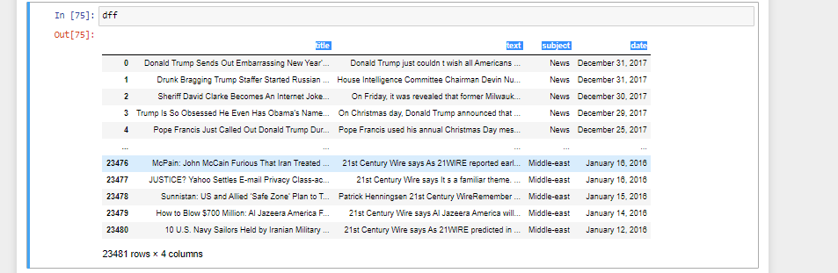

**• Analysis**

*We use different graphs to analyze the data*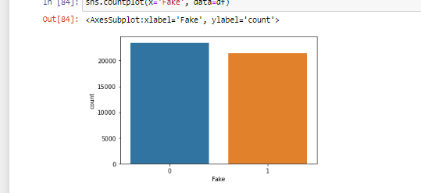

*what the data is showing*

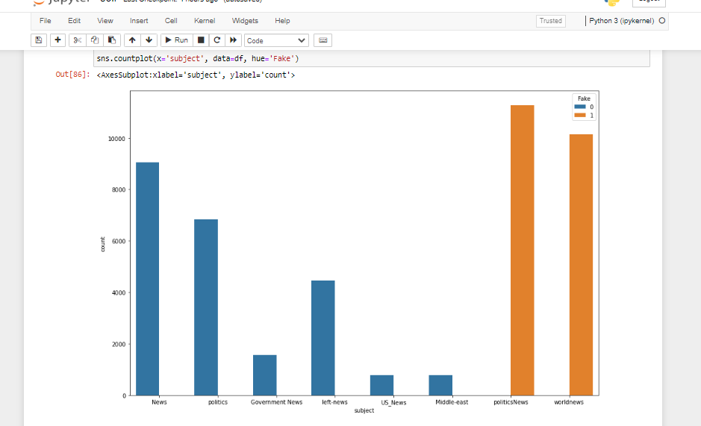

**• Implementation**

In implementation we start with preprocessing in which we remove duplicates ,check the info,and describe the dataset

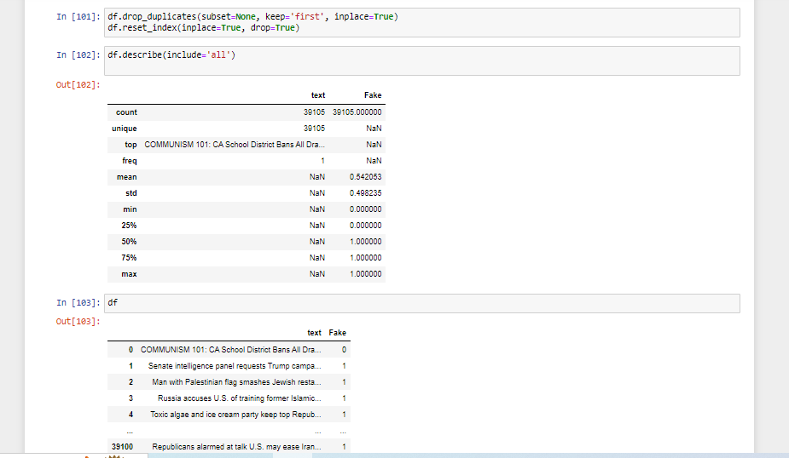

**• Preliminary Results**

**In the conclusion we train a logistic regression model to calculate the accuracy PORTER stemmer is the best choice we choosed**

.

Data Description:

## For those of us who are working academically in this problem area, I think it's important to point out that this dataset appears to be a copy of the popular ISOT dataset by the University of Victoria (unless the author can prove otherwise?). The requested citations are exactly the same. This is problematic if you're trying to demonstrate performance across different datasets and include both this dataset and the ISOT dataset in your analysis.

We have four columns in this dataset

**TITLE ,TEXT,SUBJECT,DATE**

1. Almost all real news has "Reuters", it might be reason for high recall on real news.
2. 600+ empty values in text for fake news, but text for these is present with title.
3. 1 empty string for real news. (Actually contains few spaces)
4. Many upper-case words in fake news, preserving letter cases might be useful?

Results/ Experimentation&Comparison/Analysis:

**Project Management o Implementation status report**

* **Initiation.**

Data selection From KAGGLE,Loading data in code ,Make a dataframe name **df** which we can use to perform actions

* **Planning.**

Plan how to start,which preprocessing process is required for this project, we use graphs to see visualization,Drop columns, Remove duplicates, Shuffling data, which model is best and we use logistic regression in this case.

* **Execution.**

Run the code in Jupyter notebook or in colab in this case we have used jupyter notebook, we have encountered errors while implementing the code, later we have resolved them with hard work.

* **Monitoring and control.**

Check the running program is running correctly and we see that our code is running correctly, and it is. fulfill the requirements and we see that all the desired requirements are satisfied, compatible for system and we check whether code is correctly running which means that it’s system compatible.

* **Closure**.

Project is Delivered in running condition to our Professors, Supervisors.

**accuracy score of train data : 0.9900266686150586**​

**accuracy score of test data : 0.9840606887146267**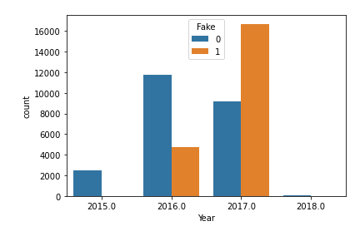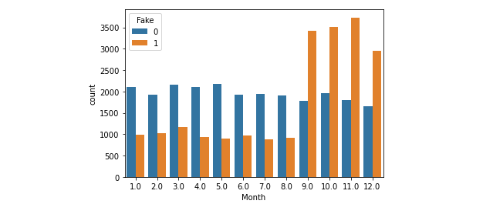

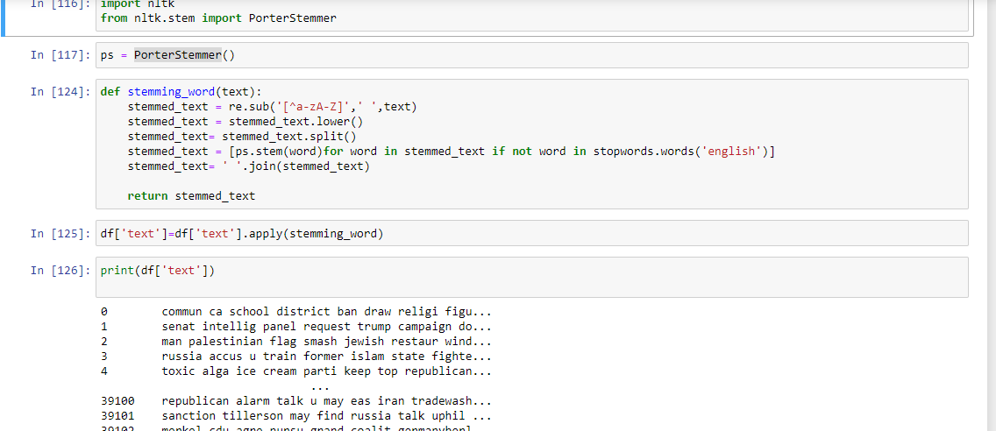

REFERENCES:

* <https://www.kaggle.com/>
* <https://www.nltk.org/howto/stem.html>
* <https://www.tutorialspoint.com/how-can-text-vectorization-be-applied-on-stackoverflow-question-dataset-using-tensorflow-and-python>

***THANKS.***